1. Introduction

In this generation, people like to travel around the world. They need to look for a comfortable hotel to stay with.

It prompted me to choose Question 2, which is to design a website with the comfortable and reasonable latest price hotel. I’ll designed the website according the evaluation 4 websites which respectively are <https://sg.hotels.com>, [www.expedia.com.sg](http://www.expedia.com.sg), [www.booking.com](http://www.booking.com) and [www.trivago.sg](http://www.trivago.sg).

The theme of the website will be based on <https://sg.hotels.com> and will be done by analysis codes sourced from Jquery.

The design guideline as the website to display the information as well.

Visitors navigate easily across the website to be able to seek the hotel they need.

This website will be built in such a way that show standard photos of hotel,color and background make visitor completing their action in a comfortable way.

The additional technical spectifications for the website are as followed to Jquery.

1. Storyboard

Home

Booking

Contact Us

Deals

Rewards

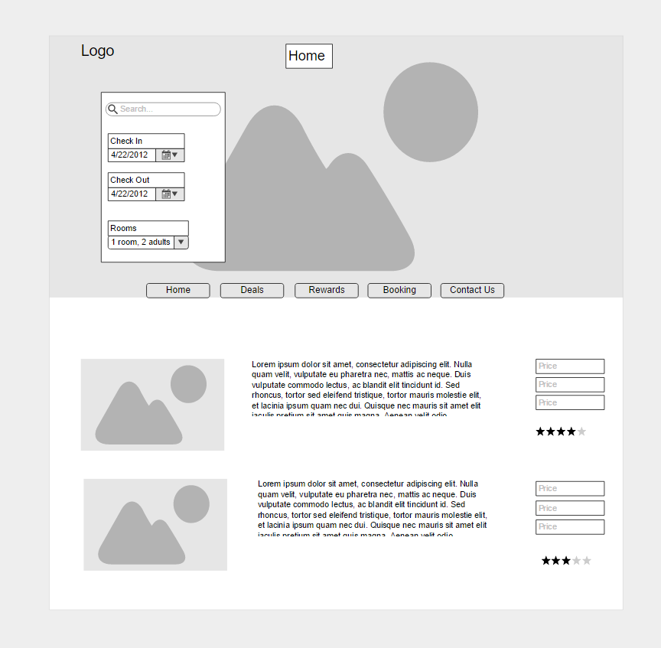

In this Home page section, there will be a title, check in/out, rooms for the featuring hotel review. The paragraph will be state information on how is the hotel and their surrounding building, nearest transport as well. The price and rating of hotel will be state beside the paragraph too.

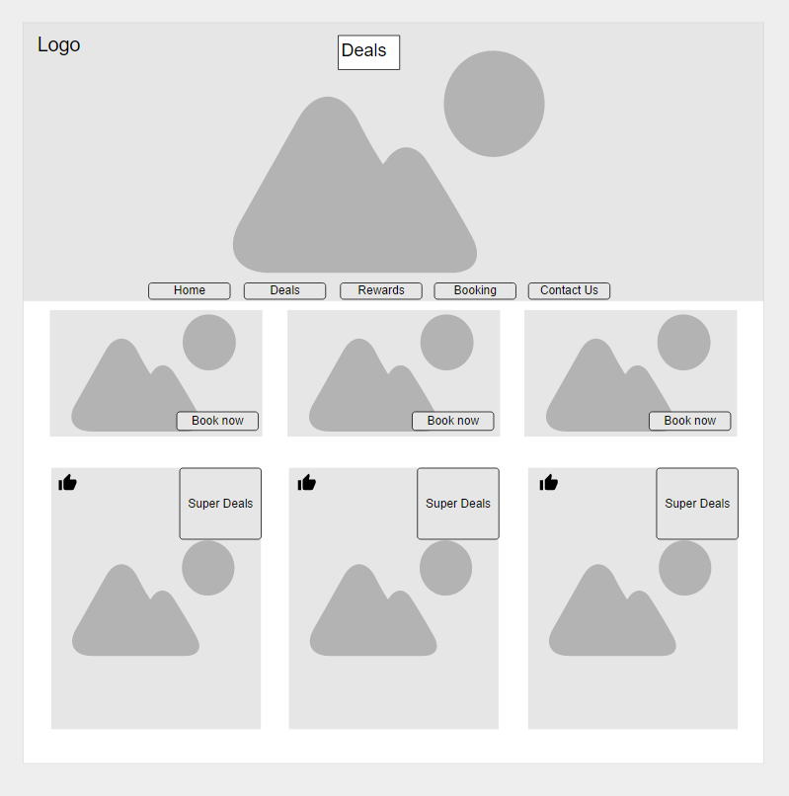

In this Deals section, the image will show with some offer and details. There will be a super deals trips for each country, it show up there so visitor won’t miss out the latest information. The like button is show that how many visitor deal with it.

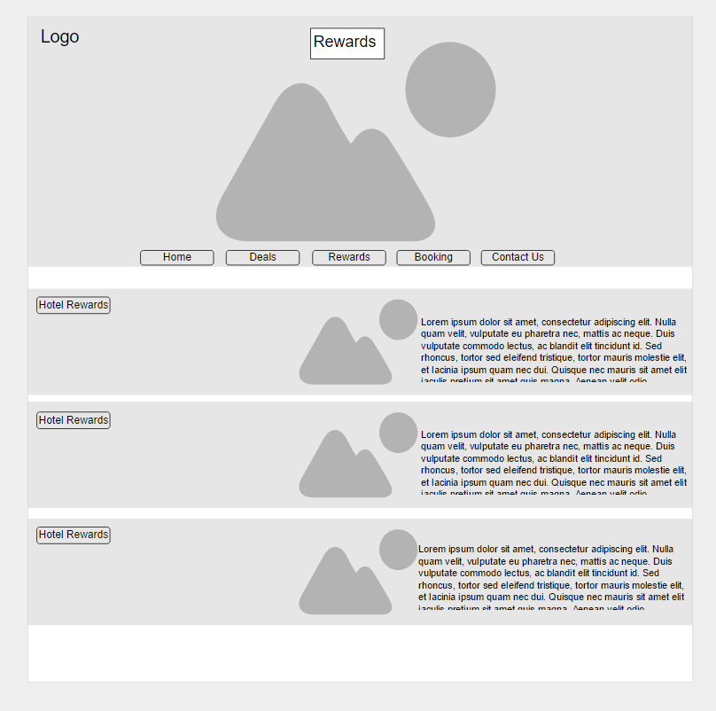

In this Rewards section, the content will show some certain hotel rewards in a limited time. Each rewards has a target to achieve by booking hotels. Visitor can get the rewards from hotel once they have enough information provided.

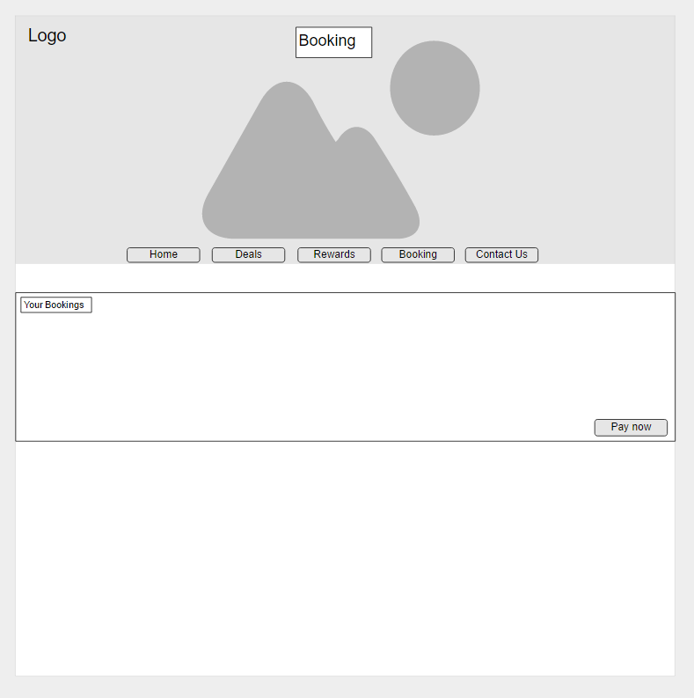

In this Booking section, visitor can come over this content once they make their decision. They can double checking the booking details before they make the payments.

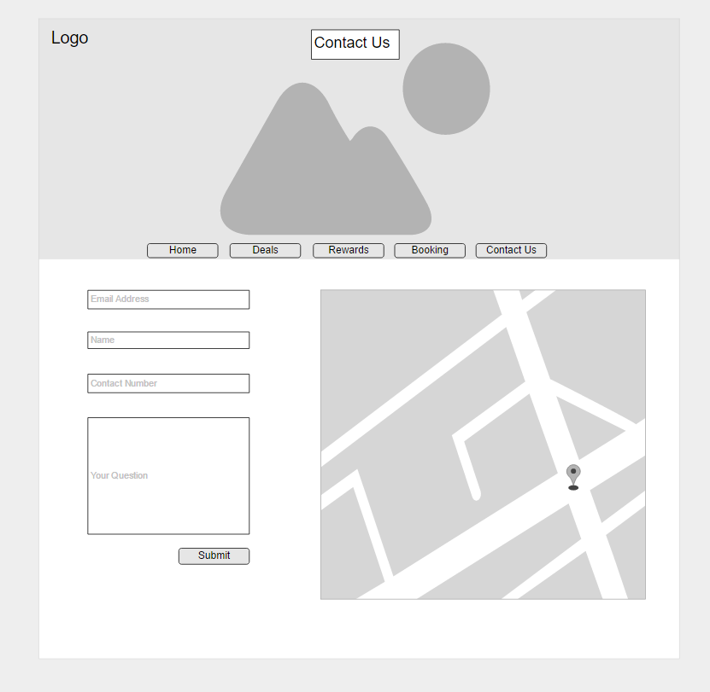

This is the last section, Contact Us. There will be a form attached for visitor to ask question by filling up their information required. The questions will be send to our official email, they will reply visitor’s question in an hour.

All the website pages will also consist of a image and a logo situated at the header of each page.

End

**Bibliography:**

Hotels.com Singapore | Hotel Booking | Accommodation Booking. Retrieved October 15, 2016, from <https://sg.hotels.com/>

@. (n.d.). Booking.com: The largest selection of hotels, homes, and vacation rentals. Retrieved October 15, 2016, from <http://www.booking.com/>

Cheap Hotels, Resorts, and Flights Booking | Travel with Expedia Singapore. (n.d.). Retrieved October 15, 2016, from <http://www.expedia.com.sg/>